**Central America ontology**

Ontology with countries in central America.

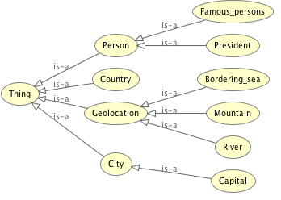

**Object properties:**

* Country has a capital
* Sea borders a country
* River is located_in a country

**A few instance examples are:**

* Salma Hayek is a famous_person born_in Mexico
* The country Nicaraguahas_capital Manuaga
* The country Mexico borders the Gulf of Mexico

Object property – Class – Instance

**Queries**

*Prefixes used for all queries*

PREFIX rdf: <http://www.w3.org/1999/02/22-rdf-syntax-ns#>

PREFIX owl: <http://www.w3.org/2002/07/owl#>

PREFIX rdfs: <http://www.w3.org/2000/01/rdf-schema#>

PREFIX xsd: <http://www.w3.org/2001/XMLSchema#>

PREFIX : <http://www.semanticweb.org/chrispool/ontologies/2015/8/central_america#>

1 - Display all countries and their capitals

SELECT ?Country ?Capital

WHERE { ?Country :has_capital ?Capital .}

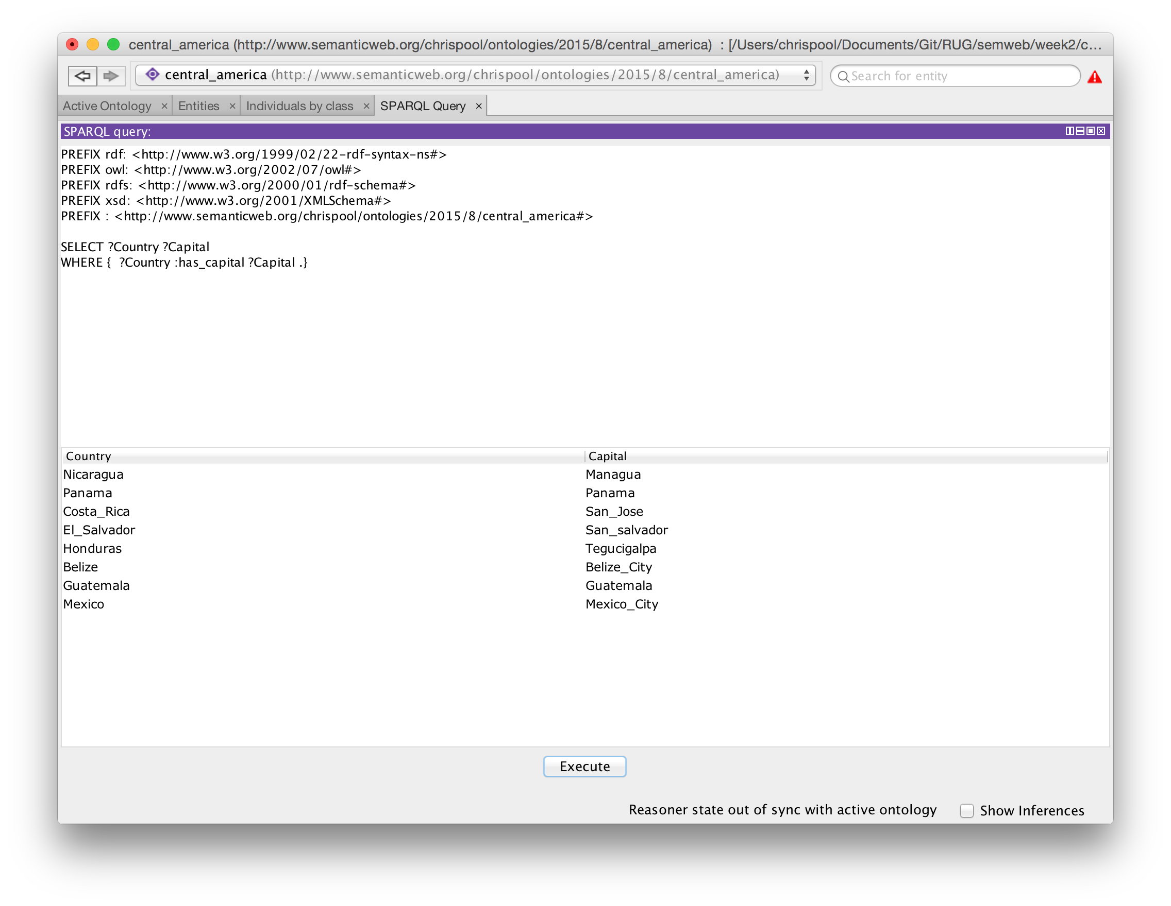

2 - Display all capitals of countries bordering the Caribbean sea

SELECT ?Country ?Capital

WHERE {

:Caribbean :borders ?Country .

?Country :has_capital ?Capital .

}

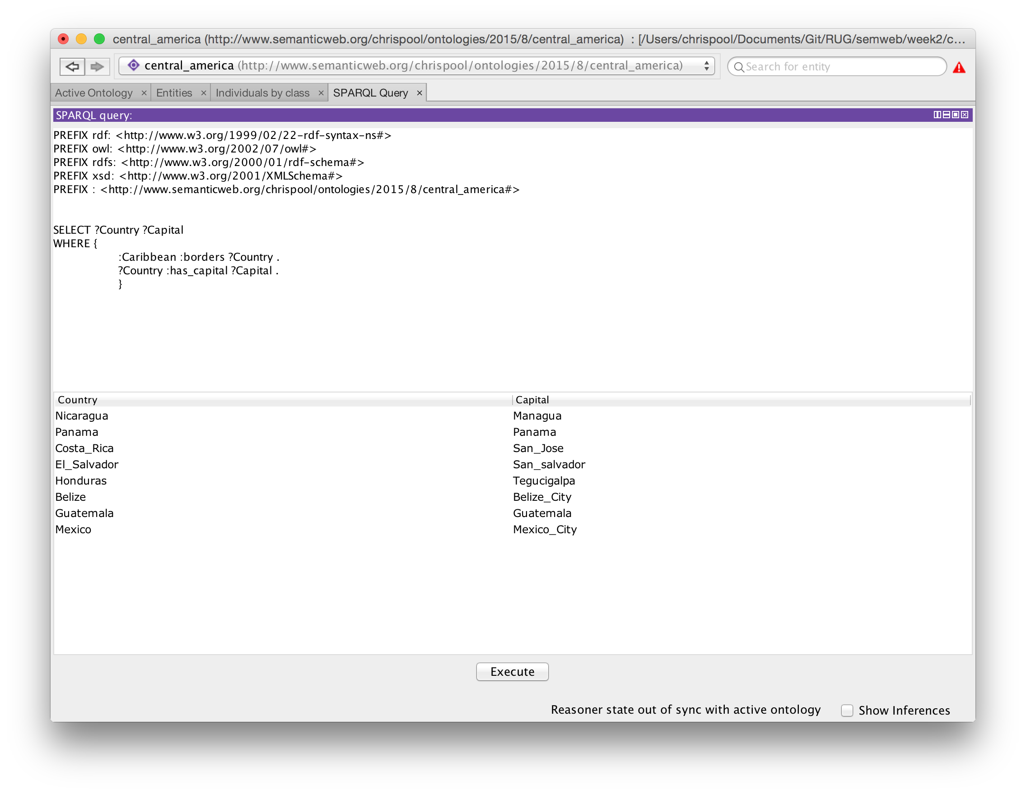

3 - Display all geolocations (only geolocations type)

SELECT ?entity

WHERE {

?entity rdf:type ?type.

?type rdfs:subClassOf* :Geolocation.

}

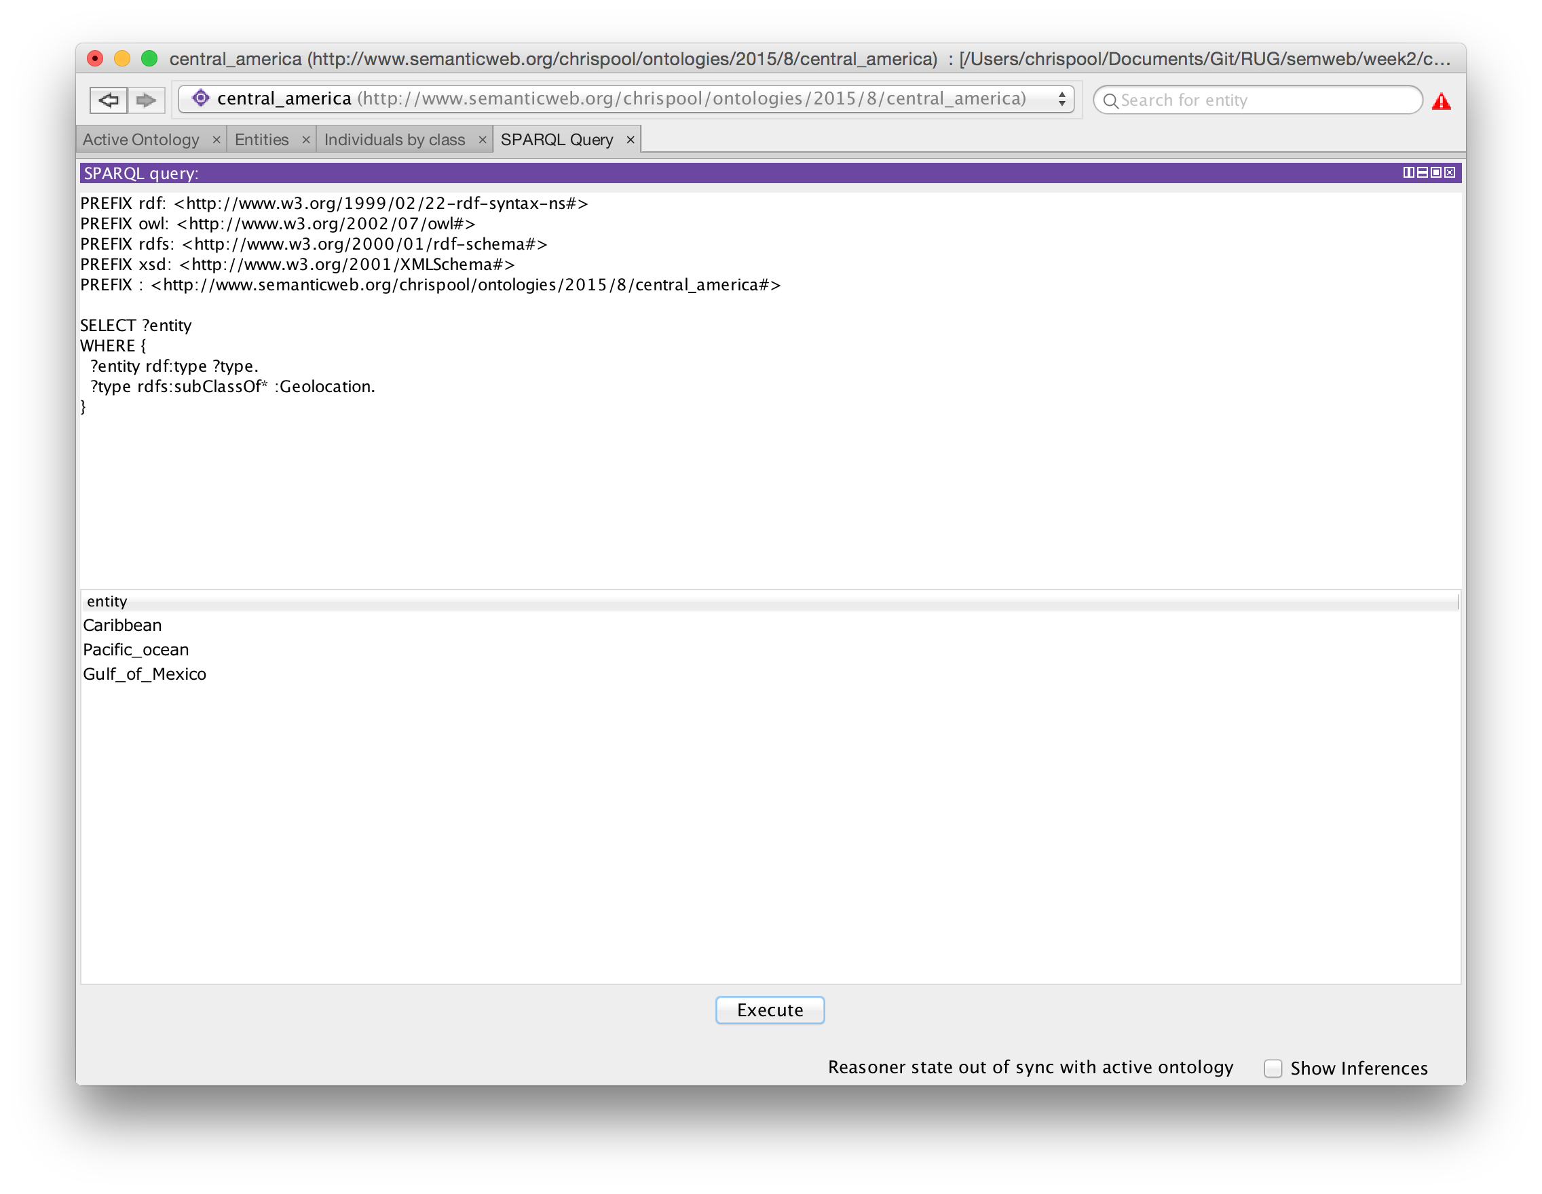

4 - Display all persons that are famous persons (subclass of persons)

SELECT ?entity

WHERE {

?entity rdf:type :Famous_person.

}

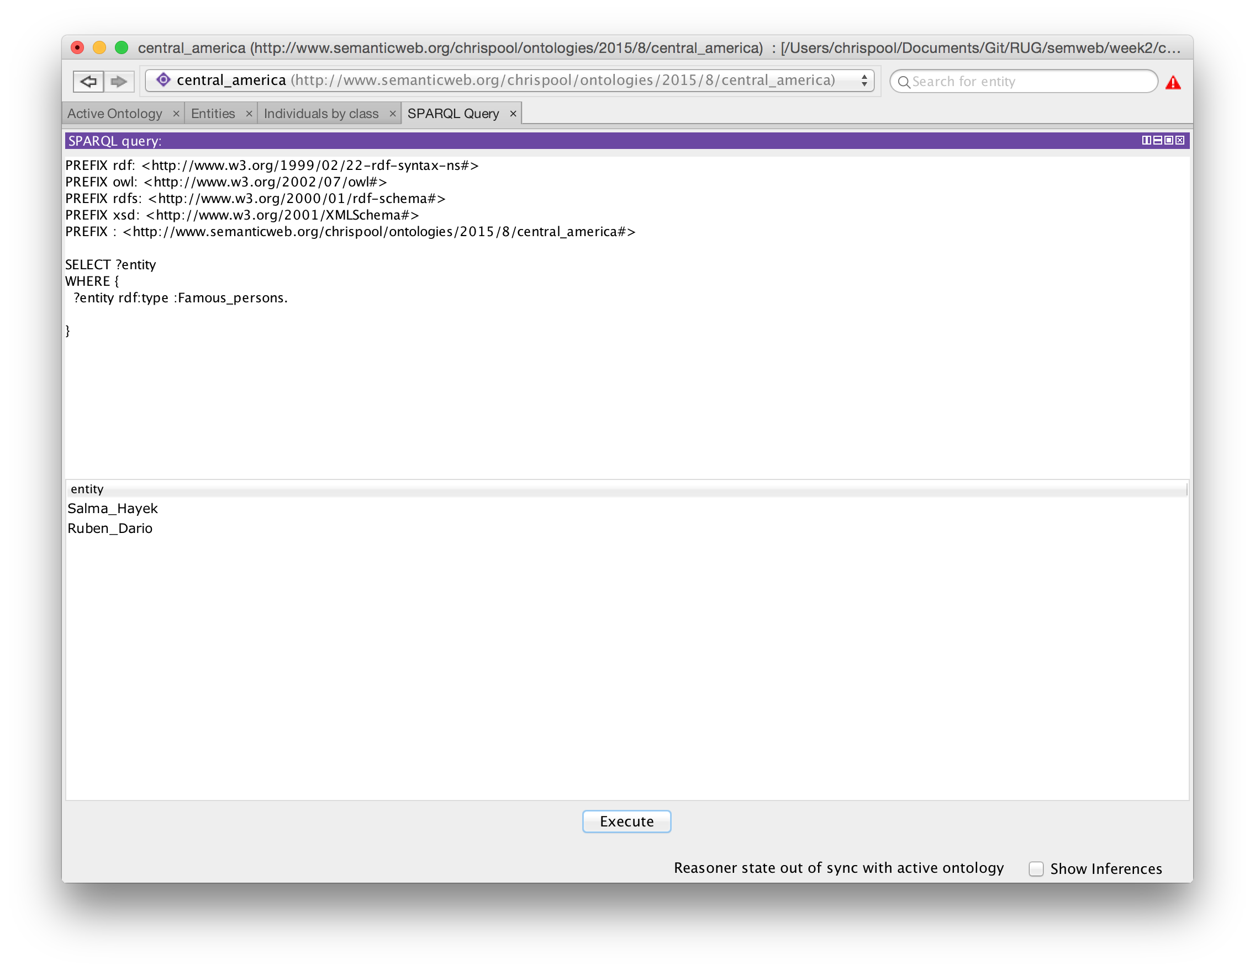

5 - Display cities that contain the combination Au

SELECT ?capital

WHERE { ?country :has_capital ?capital

FILTER regex(?capital,'^ua','i')

}

